Name of Laboratory : Electrical Workshop

|  |  |
| --- | --- |
| Lab Subject Code | : EEE1003 |
| Name of School | : SELECT |
|  |  |

**GO-DOWN WIRING**

**Ex. No. : 7** **Date** **: 29/11/2021**

**Aim**

To understand the wiring of go-down / tunnel wiring circuit.

**Materials Required**

|  |  |  |  |  |
| --- | --- | --- | --- | --- |
| **S. No.** | **Name of the apparatus** | **Range / Type** | | **Quantity** |
|  |  |  | |  |
| 1 | Incandescent Lamp | 230 V, 25 W | | 3 Nos. |
|  |  |  | |  |
| 2 | Lamp holder | 230 V, Level | | 3 Nos. |
|  |  |  |  |  |
| 3 | Switch Box | 4” x 4” |  | 4 Nos. |
|  |  |  |  |  |
| 4 | 2 way switch | 230 V, 5 | A | 3 Nos. |
|  |  |  |  |  |
| 5 | 1 way switch | 230 V, 5 | A | 1 No. |
|  |  |  |  |  |
| 6 | P. V. C. casing capping | ¼” |  | As required |
|  |  |  | |  |
| 7 | Wooden Board | 4’ x 3.5‘ | | 1 No. |
|  |  |  | |  |
| 8 | Wires | 1 sq. mm” | | As required |
|  |  |  |  |  |

**Tools Required**

Screw driver, Wire stripper, Hacksaw, combination plier, drilling machine, electrician knife

**Theory**

Godown wiring uses to operate lamps/loads in a sequential manner, where only one load operates at a time. As its name implies "Godown wiring", it is used in godowns, tunnel like structures, long passages, etc. due to the advantage of the circuit, where light is only required for passage or it requires only at one position at a time.

**Procedure**

1. Collect the materials required for this experiment.
2. Draw the layout of the given circuit diagram in the circuit board.
3. Fix the necessary materials, by using drilling machine in the layout board.
4. Terminal 2 of the bulb L1 is connected to neutral point (N) and another terminal 1 is connected to terminal 1 of switch S2.
5. Terminal 1 of the switch S1 is connected to the phase line (P).
6. Now, the terminal 2 of switch S1 is connected with terminal 2 of switch S2.
7. The terminal 3 of switch S2 is connected with terminal 2 of switch S3.
8. And terminal 3 of Switch S3 is connected with terminal 2 of switch S4.
9. After that, the terminal 3 of switch S4 is connected with terminal 1 of Bulb L4.

**Precautions**

1. Energize the circuit with the presence of Lab instructor / Faculty.
2. No part of a live circuit should be touched by the bare hand.
3. Keep the body, or any part of it, out of the circuit.

Name of Laboratory : Electrical Workshop

|  |  |
| --- | --- |
| Lab Subject Code | : EEE1003 |
| Name of School | : SELECT |
|  |  |

1. Keep the work area and workbench clear of items not used in the experiment.
2. When disassembling a circuit, first remove the source of power.

**Fuse Rating Calculations**

Power drawn by the circuit = 60 watts Voltage of the circuit = 230 volts

P = V I COS Ø

P = V x I x 1 (Assuming COS Ø = 1 for resistive load) Current in the circuit (I) = power (P) / Voltage (V)

= 60 W / 230 V = 0.260 AMP.

Fuse rating of the circuit= rounding off the current to the nearest 5 = 5A (Normally fuses are available in the ratings of 5A, 10A and etc.)

**Circuit Diagram**

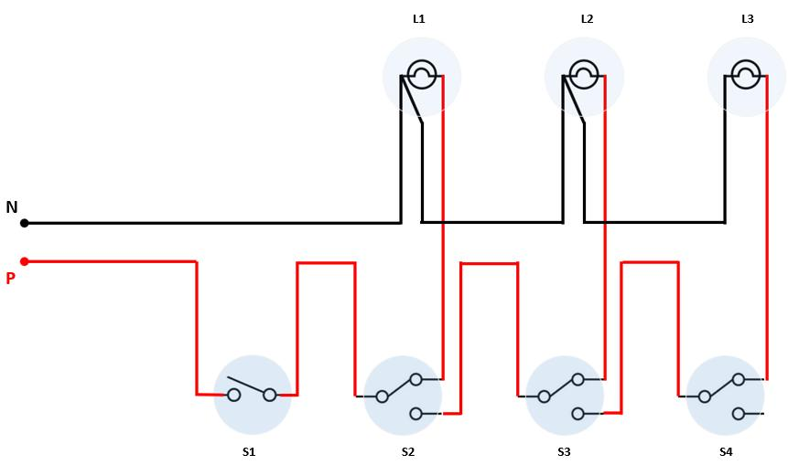

S1 : 1-way switch, S2 – S4 : 2-way switches. L1 – L3 : 25W, 230V Lamps

|  |  |  |  |  |  |  |  |  |  |  |  |  |  |  |  |  |  |  |  |
| --- | --- | --- | --- | --- | --- | --- | --- | --- | --- | --- | --- | --- | --- | --- | --- | --- | --- | --- | --- |
|  | Name of Laboratory : Electrical Workshop | | | | | | |  |  |  |  |  |  |  |  |  |  |  |  |
|  | Lab Subject Code | | | : EEE1003 | |  |  |  |  |  |  |  |  |  |  |  |  |  |  |
|  | Name of School | | | : SELECT | |  |  |  |  |  |  |  |  |  |  |  |  |  |  |
|  |  |  |  |  |  |  |  |  |  |  |  |  |  |  |  |  |  |  |  |
|  | **Observation** | | |  |  |  |  |  |  |  |  |  |  |  |  |  |  |  |  |
|  |  |  |  |  |  |  |  |  |  |  |  |  |  |  |  |  |  |  |  |
|  | **Condition** |  |  |  | **Expected conditions** | | |  |  |  |  | **Observed conditions** | | | |  |  |  |  |
|  |  |  |  |  |  |  |  |  |  |  |  |  |  |  |  |  |  |  |
|  | **No** | **S1** |  | **S2** | **S3** | **S4** | **L1** | **L2** | **L3** | **S1** | **S2** |  | **S3** | **S4** | **L1** | **L2** | **L3** | |  |
|  |  |  |  |  |
|  |  |  |  |  |  |  |  |  |  |  |  |  |  |  |  |  |  |  |  |
|  | 1 |  |  | 1 | 1 | 1 | ON | OFF | OFF | ON | 1 |  | 1 | 1 | ON | OFF | OFF | F |  |
|  |  |  |  |  |  |  |  |  |  |  |  |  |  |  |  |  |  |  |  |
|  | 2 | ON |  | 2 | 1 | 1 | OFF | ON | OFF | ON | 2 |  | 1 | 1 | OFF | ON | OFF |  |  |
|  |  |  |  |  |  |  |  |  |  |  |  |  |  |  |  |  |  |  |  |
|  | 3 |  |  | 1 | 2 | 1 | OFF | OFF | ON | ON | 1 |  | 2 | 1 | OFF | OFF | ON |  |  |
|  |  |  |  |  |  |  |  |  |  |  |  |  |  |  |  |  |  |  |  |
|  | 4 |  |  | 1 | 1 | 1 | OFF | OFF | OFF | ON | 1 |  | 1 | 1 | OFF | OFF | OFF |  |  |
|  |  |  |  |  |  |  |  |  |  |  |  |  |  |  |  |  |  |  |  |
|  | 5 | OFF |  | 2 | 1 | 1 | OFF | OFF | OFF | ON | 2 |  | 1 | 1 | OFF | OFF | OFF |  |  |
|  |  |  |  |  |  |  |  |  |  |  |  |  |  |  |  |  |  |  |  |
|  | 6 |  |  | 1 | 2 | 1 | OFF | OFF | OFF | ON | 1 |  | 2 | 1 | OFF | OFF | OFF |  |  |
|  |  |  |  |  |  |  |  |  |  |  |  |  |  |  |  |  |  |  |  |

**Result**

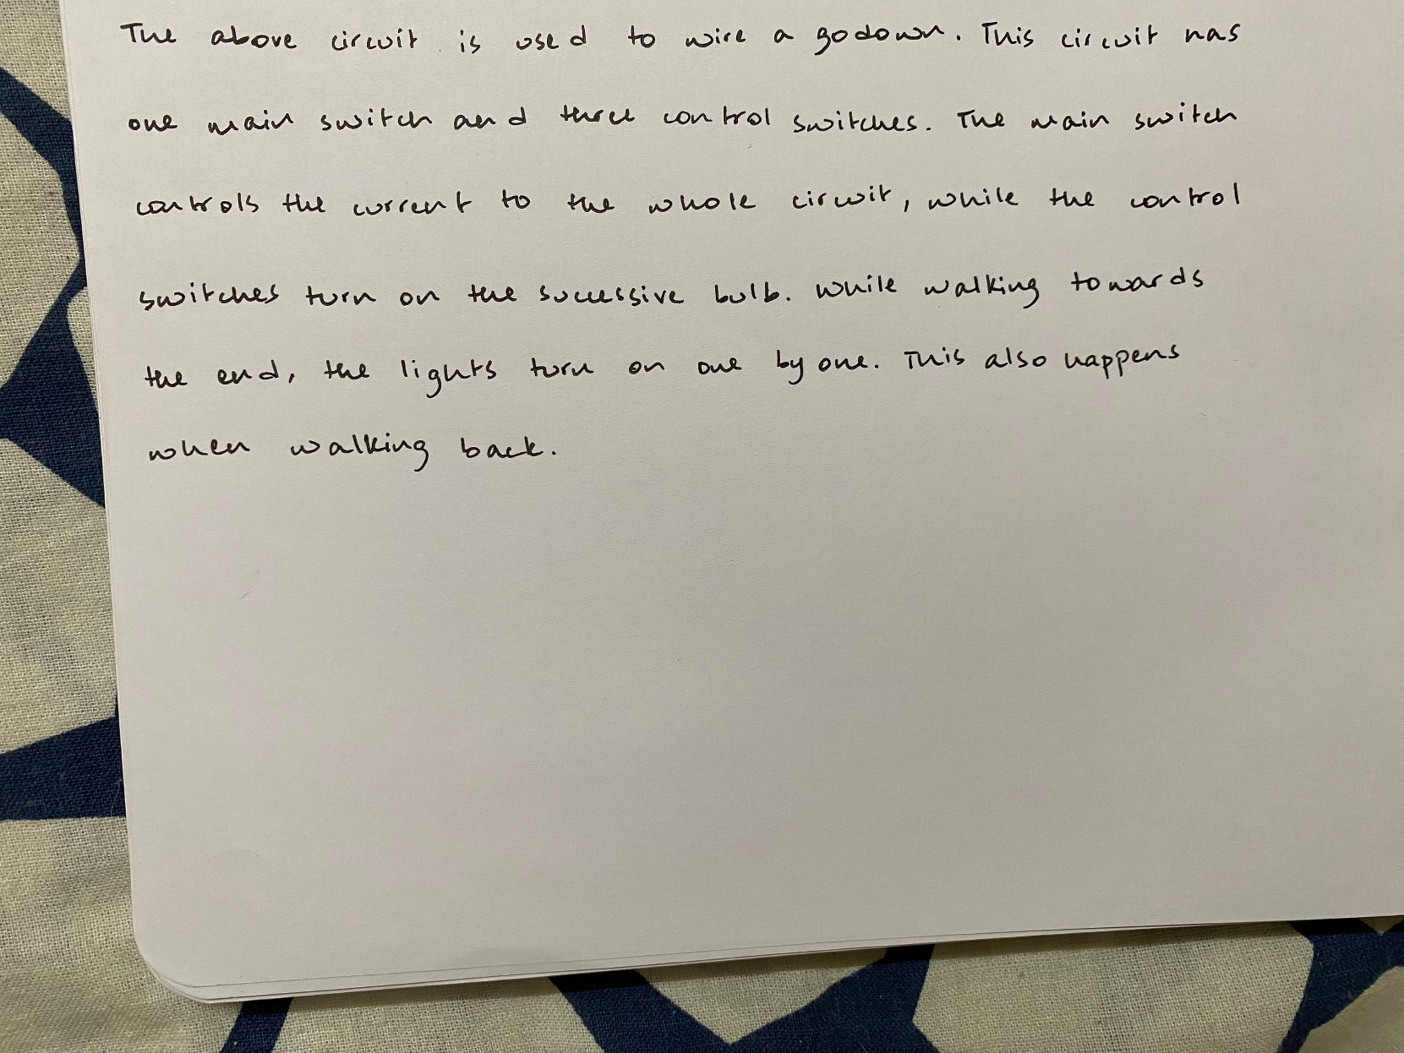

**Reg. No: 21BDS0340 Name: Abhinav Dinesh Srivatsa Date: 29/11/2021**